**This assignment is to be completed without a calculator unless otherwise noted. Work all problems neatly, in order, on a separate sheet of paper. This is due on the first day of school. It counts as two un-droppable homework grades. There will be a quiz over this material. NO WORK, NO CREDIT.**

***For #1 – 13, find the x and y-intercepts. State the domain and range. Sketch the graph.***

**1.  2.  3. **

**4.  5.  6. **

**7.  8.  9. **

**10.  11. **

**12.  13. **

***For #14 – 17, find horizontal/vertical/slant asymptotes, symmetry and intercepts. Sketch the graph.***

**14.  15.  16.  17. **

***For #18 – 21, solve.***

**18.  19.  20.  21. **

***For #22 – 34, evaluate.***

**22.  23.  24.  25.  26. **

**27.  28.  29.  30.  31. **

**32.  33.  34. **

***For #35 – 43, solve.***

**35.  36.  37. **

**38.  39.  40. **

**41.  42.  43. **

***For #44 – 55, solve using a CALCULATOR. Round your answers to three decimal places.***

**44.  45.  46.  47. **

**48.  49.  50. **

**51.  52.  53. **

**54.** The number of students infected with the flu *t* days after exposure is modeled by .

**(a)** How many students were infected after three days?

**(b)** When will 100 students be infected?

**55.** Exponential growth is modeled by . A culture contains 500 bacteria when . After an hour, the number of bacteria is 1200.

**(a)** How many bacteria are there after four hours?

**(b)** After how many hours will there be 8000 bacteria?

***For #56 – 61, evaluate using the given graph of f(x).***

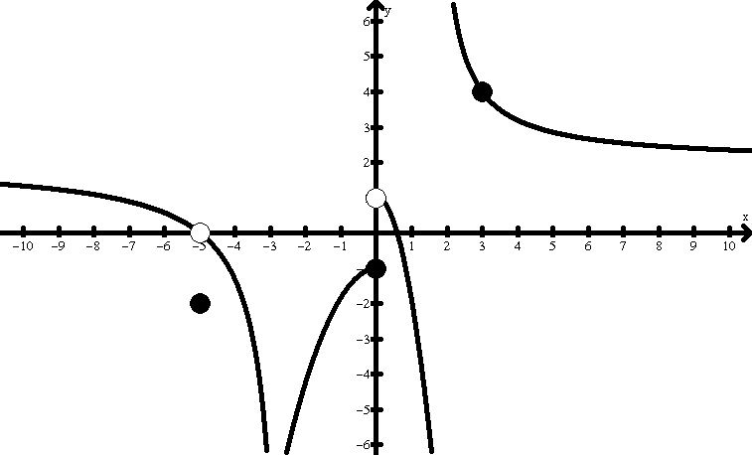

**56.  57. **

**58.  59. **

**60.  61. **

***For #62 – 75, evaluate.***

**62.  63.  64. **

**65.  66.  67. **

**68.  69.  70. **

**71.  72.  73. **

**74.  (a)  (b)  (c) **

**75.  (a)  (b) **

***Use the definition of derivative (the long way) to find the derivative.***



**76.  77.  78.  79. **

***Use the differential rules (the shortcut) to find the derivative.***

**80.  81.  82. **

**83.  84. **

**85.** Given the function .

**(a)** Find .

**(b)** Write the equation of the tangent line to *f* at .